### Projects 6-8

### 

### Projects 6-10

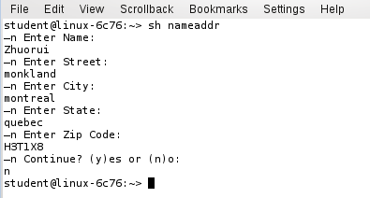

### sh Billing

Algorithm:

Read(price)

Read(quantity)

total=Calculate(price,quantity)

Output(total)

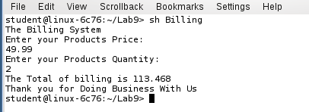

### sh Billing1

Algorithm:

Loop {

Read(price)

Read(quantity)

total=Calculate(price,quantity)

Output(total)

} //loop end

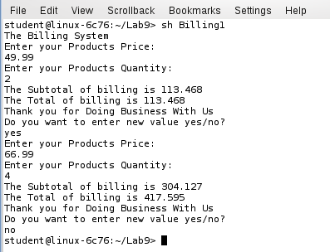

### sh Conversion

Algorithm:

Loop {

Read(CAD)

USD=Calculate(CAD )

Output(USD)

} //loop end

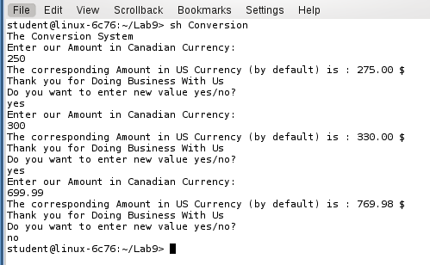

### sh Story

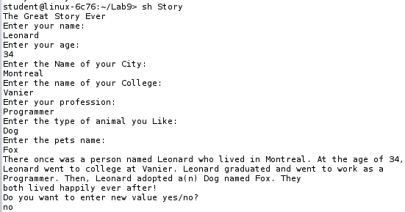

### sh Payroll

